OSPAR COMMISSION
for the protection and conservation of the marine environment of the North-East Atlantic

CALL FOR TENDER
“ Development and Maintenance of the OSPAR Riverine Inputs and Direct Discharges (RID)+ Database”

Name, addresses and contact point(s):
Official name: OSPAR Commission
Postal address: The Aspect, 12 Finsbury Square, London EC2A 1AS
Contact point: Tarquin Dorrington, Deputy Secretary, OSPAR
Telephone: +44 (0)20 7430 5200
E-mail: secretariat@ospar.org
Web: www.ospar.org

Title attributed to the contract
Development and Maintenance of the OSPAR RID+ Database

Description of the contract
Overview
The OSPAR Commission is an international intergovernmental organisation established to protect the marine environment in the North-East Atlantic. It is the mechanism by which 15 Governments and the EU cooperate to protect the marine environment of the North-East Atlantic. The Contracting Parties are: Belgium, Denmark, Finland, France, Germany, Iceland, Ireland, Luxembourg, the Netherlands, Norway, Portugal, Spain, Sweden, Switzerland, the United Kingdom of Great Britain and Northern Ireland and the European Union. The Commission is administered by a Secretariat based in London. The working languages are English and French.
Monitoring and assessment data are collected by Contracting Parties to fulfil obligations under the OSPAR Convention to deliver joint assessment and monitoring products. Data are analysed for annual committee assessments, periodic evaluations as well as contributing to decadal integrated assessments on the quality of the marine environment of the North-East Atlantic (e.g. Quality Status Report 2023). The OSPAR Riverine Inputs and Direct Discharges (RID) programme aims to monitor and assess all inputs and discharges of selected contaminants to the OSPAR Maritime Area and its regions that are carried via rivers into tidal waters, or are discharged directly into the sea, for example through sewage pipelines or activities like aquaculture inputting substances directly.
The RID programme currently focuses on mandatory monitoring and reporting of the concentrations and loads of the metals cadmium, copper, lead, mercury and zinc, the organic pollutant lindane, nitrogen and phosphorus species, and suspended particulate matter. Monitoring of Polycyclic aromatic hydrocarbons (PAHs), mineral oil, polychlorinated biphenyls (PCBs) and other hazardous substances, especially organohalogens, are recommended for voluntary monitoring. Furthermore, it is mandatory to monitor flow, and to make estimates of both flow and load from unmonitored areas.
OSPAR is seeking proposals for a fully costed, technical specification for the build, implementation, deployment and on-going maintenance of a renewed OSPAR RID Database to meet the needs of OSPAR Contracting Parties (CPs). The response to this request should build on work undertaken to date, where appropriate, and decisions taken by the OSPAR Commission. A new RID Database, named the “RID+ Database” (RID Plus) is envisioned as a replacement for the current RID Database, addressing shortcomings of the latter and providing enhanced functionality to meet the evolving needs of OSPAR and its Contracting Parties.
Further background on hazardous substances can be found in the thematic and indicator assessments provided for OSPAR’s 2023 Quality Status Report here.
Further information about the OSPAR Commission can be obtained from the Commission’s website at www.ospar.org.
Aim and objectives
The objective of this project is to design, build, and maintain an OSPAR RID+ Database to meet the needs of OSPAR Contracting Parties, in line with the outline specification set out in Annex A to this call. The response to this request should build on work undertaken to date, where appropriate, and decisions taken by the OSPAR Commission.

Tasks and products
The response to the call should incorporate the following elements:
  - Detailed technical specification: outlining the proposed structure of the system inclusive of hosting requirements;
  - Implementation plan: clear action plan for the build and testing phase with provision of a separately costed maintenance and hosting plan for two years following project delivery;
  - Detailed project budget breakdown: inclusive of the build and data migration (including reporting forms) and separate proposed maintenance schedule with outlined potential hosting costs (including any projected growth);
  - Project timeline: clearly timed delivery proposal aligned with the implementation plan;
  - Relevant previous experience: any examples of existing systems that can be reviewed as indicative of the type of product that can be expected.

Duration of the contract and timing of deliverables
Start date: 15/11/24
Inception report delivery by: 15/12/24
Technical specification document by: 31/12/24
Expected delivery date for database, for approval by OSPAR: 15/09/25
Maintenance and hosting: 01/10/25 – 01/10/27

Type of tender
Open

Estimated level of provision of technical assistance
It is envisaged that the work will be conducted remotely, at the contractor’s premises. The tender should budget for up to three online (or in-person, with a hybrid component) meetings with the project steering group. If travel is necessary for the purposes of the delivery of the technical assistance it shall be agreed with the OSPAR project manager. Reasonable travel and subsistence costs associated with this additional travel will be reimbursed by the OSPAR Secretariat and should not be included in the tender.
The budget for the development and build of the database in this contract should be in the region of EUR 175 000 excluding VAT and expenses. A separate costing should be provided for the maintenance of the database.

Selection criteria and weighting:
Criteria | Weighting (%)
Alignment of proposed approach with OSPAR's requirements and recommendations | 25
Timeliness and feasibility of project execution | 25
Demonstrated experience and expertise in database development and maintenance and preferably experience working with environmental data. | 25
Value for money | 25

Management, delivery and completion of the work
Work under this proposal will be managed by the OSPAR RID Data Task Group, consisting of national experts in riverine inputs and direct discharges and data management with support from the OSPAR Commission Secretariat data team. The contract will be with the OSPAR Commission, as represented by the Executive Secretary. All deliverables must be submitted to the OSPAR Secretariat.

Annex A

Invitation to Tender: Development and Maintenance of the OSPAR Riverine Inputs and Direct Discharges (RID)+ Database

OSPAR is seeking proposals for a fully costed, technical specification for the build, implementation, deployment and on-going maintenance of a renewed OSPAR Riverine Inputs and Direct Discharges (RID) Database to meet the needs of OSPAR Contracting Parties (CPs). The response to this request should build on work undertaken to date, where appropriate, and decisions taken by the OSPAR Commission. A new RID Database, named the ”RID+ Database” (RID Plus) is envisioned as a replacement for the current RID Database, addressing shortcomings of the latter and providing enhanced functionality to meet the evolving needs of OSPAR and its Contracting Parties.
Responses to this invitation should include a fully costed specification for the following deliverables of the RID+ database invitation to tender:
- development and data migration (including reporting forms); and
- maintenance and system administration.

Context
Monitoring and assessment data are collected by Contracting Parties to fulfill obligations under OSPAR to deliver joint assessment and monitoring products. Data are analysed for annual committee assessments, periodic evalutations as well as contributing to decadal integrated assessments on the quality of the marine environment of the North-East Atlantic (OSPAR Quality Status Reports - QSR).
The OSPAR Convention specifies a range of data, monitoring, and reporting obligations. Annex IV to the OSPAR Convention “on the assessment of the quality of the quality of the marine environment” provides for cooperation in monitoring programs, joint quality assurance arrangements, the development of scientific assessment tools, and the preparation of assessments.
There are data release arrangements defined in Annex III of the Rules of Procedure of the OSPAR Commission , stating that:
- OSPAR is committed to making as much information as possible publicly available;
- Data-handling arrangements should ensure that properly documented, quality-controlled and comparable data sets are available;
- Data-handling arrangements should also make efficient use of resources and be clear and transparent, while protecting the privacy and confidentiality of individuals and commercial interests.
To deliver on this, the OSPAR Commission has agreed the OSPAR Data Policy (https://odims.ospar.org/en/data_policy/) which states that OSPAR data are licensed according to Creative Commons Zero.
The OSPAR Riverine Inputs and Direct Discharges programme aims to monitor and assess all inputs and discharges of selected contaminants to the OSPAR Maritime Area and its regions that are carried via rivers into tidal waters, or are discharged directly into the sea, for example through sewage pipelines or activities like aquaculture inputting substances directly.
The RID programme currently focuses on mandatory monitoring and reporting of the concentrations and loads of the metals cadmium, copper, lead, mercury and zinc, the organic pollutant lindane, nitrogen and phosphorus species and suspended particulate matter. Monitoring of Polycyclic aromatic hydrocarbons (PAHs), mineral oil, polychlorinated biphenyls (PCBs) and other hazardous substances, especially organohalogens, are recommended for voluntary monitoring. Furthermore it is mandatory to monitor flow, and to make estimates of both flow and load from unmonitored areas.
The programme is governed through OSPAR Agreement 14-04. Further details are available on the OSPAR website: https://www.ospar.org/work-areas/hasec/hazardous-substances/rid

Background
The OSPAR RID database was developed as a trend assessment tool for the QSR 2010. It is an Microsoft Access (file-based) database, storing data describing annual Riverine Inputs and Direct discharges to the North-East Atlantic from OSPAR Contracting Parties.
Data are reported annually by Contracting Parties using a set of Microsoft Excel templates (Annex 3) to the data manager, who is responsible for checking the incoming data, uploading the data to the Microsoft Access database and producing an annual data report. In addition to the annual report, more detailed analyses are made in conjunction with periodic evaluations and the QSR. RID Data Reports are then published via the OSPAR Data and Information Management System (ODIMS): https://odims.ospar.org/en/search/?datastream=rid.
Ongoing work by OSPAR Contracting Parties to agree safe maximum nutrient loads to the sea will require new, annual, data analysis processes to follow-up implementation of the agreement. New developments, increasing difficulties in supporting the aging database and difficulties with data reporting templates, no functionalities to support quality assurance, and lack of a proper user interface have highlighted the need to modernise both the database, and its data management.
The Helsinki Commission for the Protection of the Baltic Environment (HELCOM) and OSPAR work closely with each other, with several Contracting Parties having shared sea areas. HELCOM experienced similar issues to OSPAR and has successfully developed and implemented a new database system called HELCOM PLUS (Pollution Load User System) currently hosted by Stockholm University. HELCOM PLUS therefore addresses many of the problems experienced with the current OSPAR database. HELCOM PLUS has therefore been identified as a suitable basis for the OSPAR RID+ database.
Data integrity and quality are paramount for OSPAR assessments, and the current RID database is now falling short in enabling the implementation of robust data quality procedures and accommodating changes in rivers, parameters, or borders. An initial feasibility study has been carried out to consider the transfer of RID data to a new database and considered the technical feasibility of migrating RID data to a database structure similar to HELCOM PLUS. It was concluded that utilising a structure similar to HELCOM PLUS would offer numerous advantages in storage, quality assurance, and accessibility, when compared to the current arrangement. It should be noted that the HELCOM PLUS system has been developed using open source and freeware software, and a version will be provided free of charge for OSPAR.
The structure of the current Microsoft Access database is shown in Annex 1. The entity-relationship diagram for HELCOM PLUS is shown in Annex 2.

Data use outside OSPAR
Data reported to OSPAR are also used by Contracting Parties to report against, national, regional and international obligations. It is the expectation that data collected under the auspices of OSPAR should, where appropriate, contribute to the data and information needs for implementation of the EU Marine Strategy Framework Directive (MSFD).
The OSPAR Convention provides a regional framework for Contracting Parties to work together towards fulfilling their obligations under other international conventions and processes. Examples include the Convention on Biological Biodiversity (CBD) and the UN Regular Process for Global Reporting and Assessment of the Marine Environment, including Socio-economic Aspects (the World Ocean Assessment). In this broader context, interoperability with similar systems, e.g., those implemented through other Regional Seas Conventions, is required.

Scope of Work
Work involves the development and implementation of a database system to manage OSPAR Riverine Input and Direct Discharge Data. Data describe inputs via monitored and unmonitored rivers as well as inputs from direct discharges (e.g. outlets from wastewater/sewage treatment plants). Data are reported annually, with an annual resolution, although the option to store monthly and daily inputs is of interest. At present, reporting of inputs cover the substances Cadmium, Copper, Lead, Zinc, g-HCH, PCBs, Ammonium, Nitrate, Phosphate, Total nitrogen, Total phosphorus, Suspended Particulate Matter and Total Organic Carbon. Units range from kilogrammes per year for hazardous substances, to tonnes per year for metals and kilotonnes per year for nutrients. The system should be flexible enough to allow other substances to be added as needed. In addition to the actual inputs, the database needs to include information on measured concentrations and measurement quality (limits of determination and quantification) in order to permit quality control of the reported data – in particular to identify where changes in quantification and detection limits cause jumps in reported time series. Water flow data is also stored to allow flow normalisation and also analyses of the effects of climate change on inputs of substances. More detail can be found in OSPAR Agreement 14-04 and in the reporting sheets in Annex 3.
All data input to the database should be retrievable via user interfaces; public users will have access to data and information agreed for publication (OSPAR data are put through an annual validation and approval process and therefore cannot be immediately published following upload), and registered users will have access to all data/information.
Provision of user-defined outputs (i.e., temporal scope, Contracting Party, monitoring site, sea basin etc) for input to assessments should be available.
Administrators should be able to review any external data inputs, handle amendments to the data structure (including introduction of new substance types, new monitored rivers or sea sub-basins or reclassifications) and management of user accounts.
Provision of documentation for users and administrators should be made, preferably as online content within the system that can be managed and updated by database administrators and data managers.
The scientific data manager has the responsibility to check that the correct data are reported by Contracting Parties by the relevant deadlines. The scientific data manager also ensures that the scientific data quality is maintained – checking that reported laboratory analyses maintain a sufficiently high standard and that data reported are consistent with both laboratory results and previous years’ data. The scientific data manager is the interface between the database manager and the user community (OSPAR Input Working Group), supports the data reporters – including advising when data are rejected by the system - and produces the annual Input Data Report.
Open Geospatial Consortium (OGC) compliant web services are required to meet external reporting obligations, these should include Web Feature Service (WFS), Web Map Service (WMS) and Catalogue Service for the Web (CSW) as a minimum, with consideration of Web Coverage Service (WCS), Web Map Tile Service (WMTS) and other appropriate OGC standards. These services will be used as the basis for integration with OSPAR’s single access data point, the OSPAR Data and Information Management System (ODIMS).
Future application and security updates should be considered and a structure for their processing and implementation included in the response.
Tenders should address all components of the proposal with clearly itemised costs to reflect one-off development costs vs on-going maintenance costs.

Deliverables
Selected contractor(s) will be responsible for:
Component 1: RID+ development and migration/re-reporting of historical data:
- Development of RID+ based on the HELCOM PLUS structure, tailored to OSPAR's requirements.
- Provision of data submission templates for Contracting Parties to input data seamlessly into RID+. Implement quality assurance features from HELCOM PLUS reporting templates and in RID+ to function on RID data.
- Adaptation of the HELCOM PLUS software (scripts) for OSPAR's use and ensuring compatibility with RID+.
- Modify HELCOM PLUS user interface to comply with the RID+ data and user needs including, options for reporting and management of higher frequency (monthly or daily) data.
- Implement a consistent nomenclature and numbering for rivers, areas, and sources based on the specifications by OSPAR INPUT and Contracting Parties.
- Migration of historical data from the current RID Database to RID+. Some Contracting Parties will choose to re-report data, other data will be migrated directly from RID. Support the validation of the migration and the re-reporting of historical data.
- Provide an initial two-year period of maintenance and support for RID+, including user support, and system updates. This refers to both hardware and software, as required. User support covers notifications about service interruptions and technical aspects of the system. Scientific issues, such as quality control issues flagged by the system are expected to be managed between Contracting Parties and the scientific data manager.
- Provide a training session for Contracting Parties’ on database usage, and a technical session on system administration, and maintenance.
- Prepare comprehensive documentation for users and administrators, including, inter alia, the database architecture (including an entity relationship diagram (ERD)), procedure definitions (scripts), and best practices regarding data input and flow.
- The cost must include project management during the database development including meetings with a group consisting of representatives from the OSPAR Secretariat and the OSPAR RID Task Group to discuss the progress of work, deadlines, clarifying specifications and solutions, discuss obstacles, discuss testing, validation of migrated/re-reported historical data and other issues as indicated in the feasibility study.
Component 2: Database Maintenance and Administration:
- Provision of updated server and (web-based) client interfaces.
- Provision of test environment for further script development.
- Regular system monitoring and maintenance to ensure optimal database performance.
- Implement backup and disaster recovery procedures to safeguard critical data.
- Provide timely support and troubleshooting for database-related issues. Timely support implies that queries should be replied to within 24 hours. Unscheduled downtime should not exceed 24 hours in a week.

Submission Requirements
Interested contractors are requested to submit proposals, including:
- Company profile highlighting relevant experience in database/system development and maintenance, with references as appropriate.
- Proposed approach and methodology for developing and maintaining RID+.
- Detailed breakdown of costs, including development, migration, and ongoing maintenance.
- Implementation plan: clear action plan for build and testing phase with separate provision of a maintenance and hosting plan for two years following project delivery.
- Detailed project budget breakdown: inclusive of the build and separate proposed maintenance schedule with outlined potential hosting costs (including any projected growth).
- Project timeline: clearly timed delivery proposal aligned with the implementation plan.
- Strong commitment to data security and compliance with relevant regulations.
- Excellent communication skills and ability to work collaboratively with our team.
- Timeline for project execution, including key milestones and deliverables.

Completion and delivery of the work
Work under this proposal will be managed by the OSPAR RID Data Task Group, consisting of national experts in riverine inputs and direct discharges and data management with support from the OSPAR Commission Secretariat data team. The contract will be with the OSPAR Commission, as represented by the Executive Secretary.
Please address and submit your tender proposals to:
secretrariat@ospar.org

Evaluation Criteria
Tender proposals will be evaluated in line with the submission criteria and based on the following criteria:
Criteria | Weighting (%)
Alignment of proposed approach with OSPAR's requirements and recommendations | 25
Timeliness and feasibility of project execution | 25
Demonstrated experience and expertise in database development and maintenance and preferably experience working with environmental data. | 25
Value for money | 25

OSPAR reserves the right to accept or reject any proposal and to annul the tender process at any time without liability.
We look forward to receiving your proposals and potentially collaborating with you on this important project for OSPAR.

Annex 1 – Structure of the existing RID database
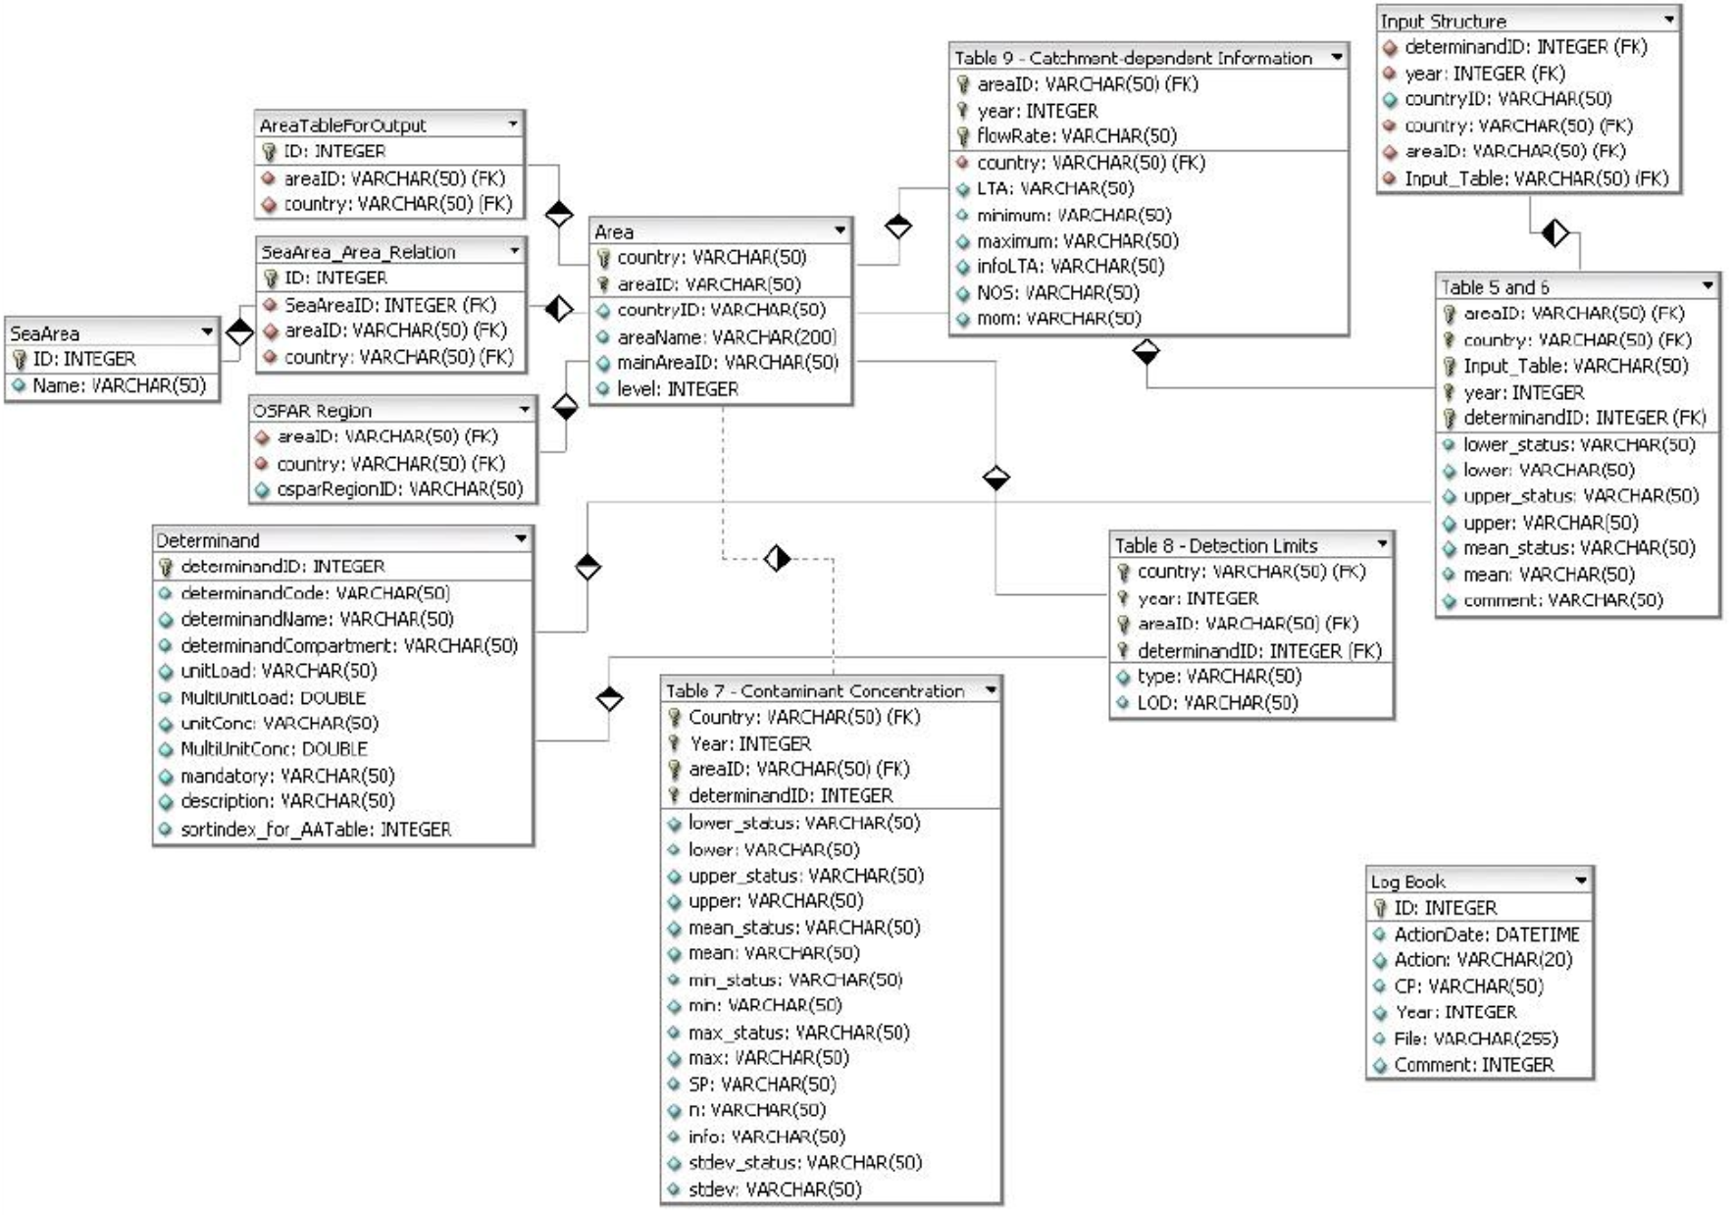

Annex 2 – Entity Relationship Diagram of the HELCOM PLUS database (HELCOM PLUS 4/2013 doc 03/01)
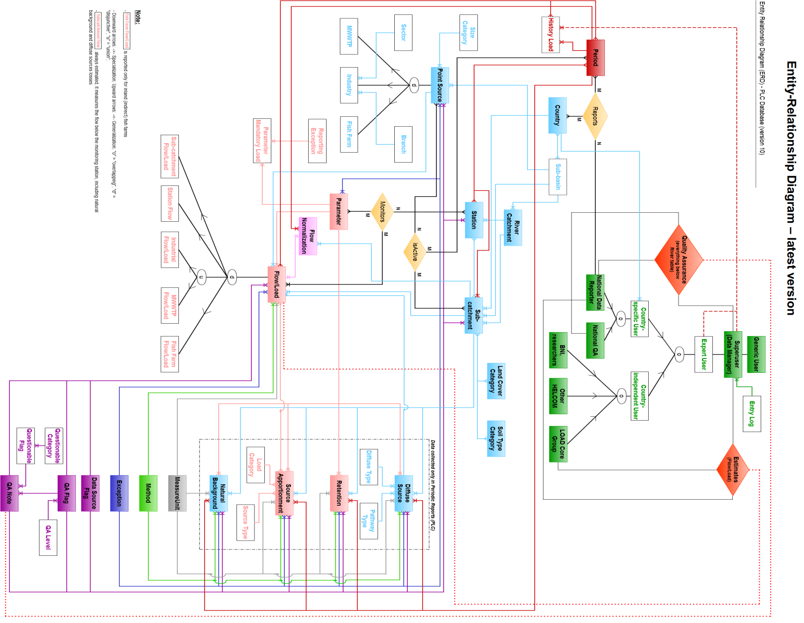

Annex 3 – Reporting forms for the existing RID database
- Table 5 - Data reporting sheets for direct discharges
Table 5a Sewage effluents | 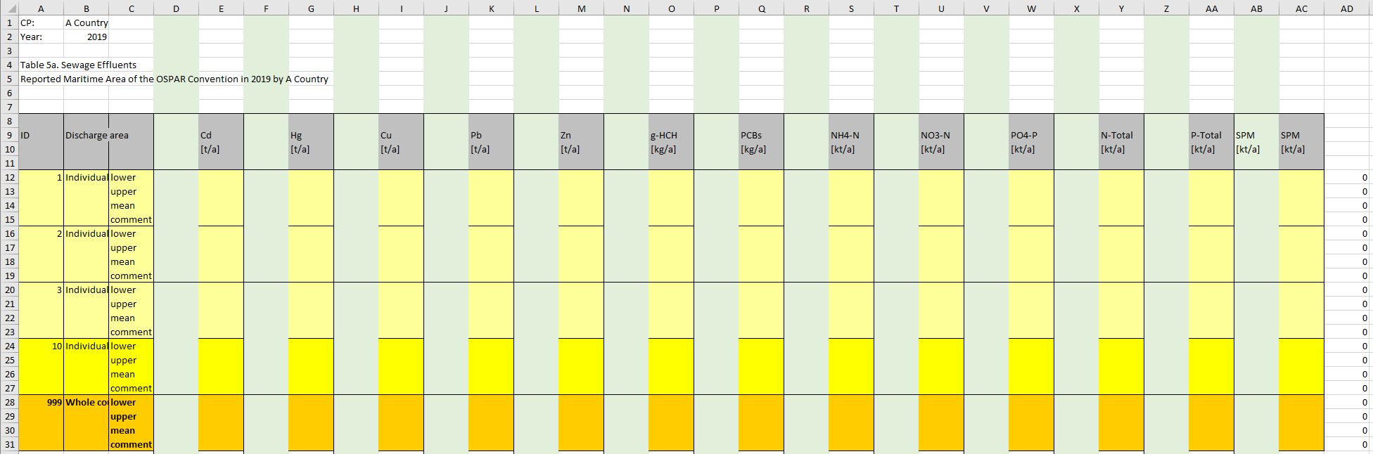
Table 5b Industrial effluents | 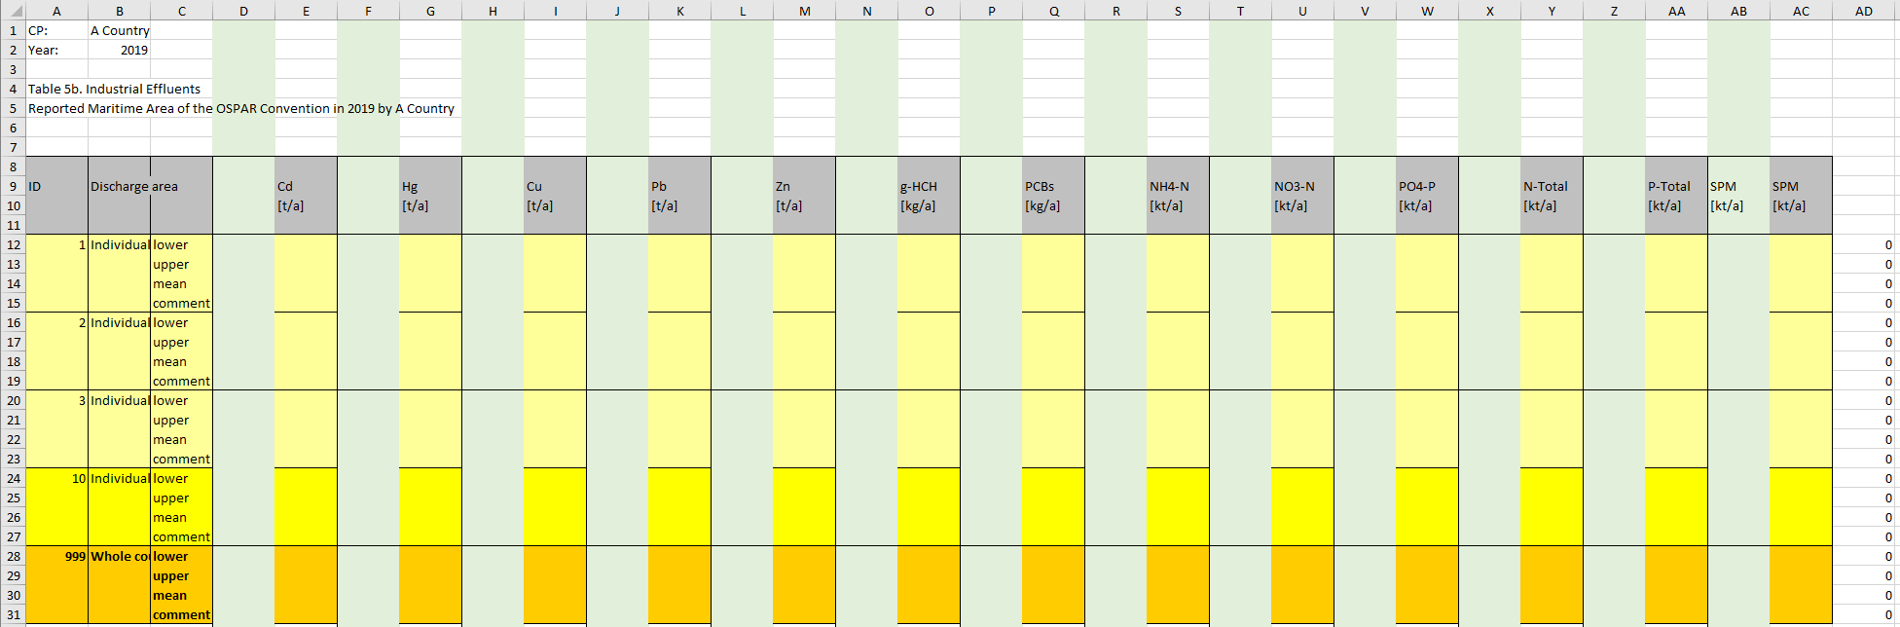
Table 5c Aquaculture discharges | 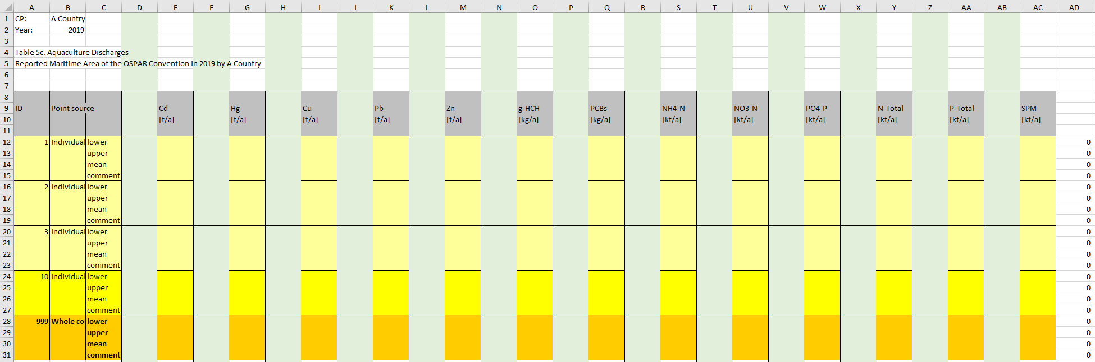
Table 5d Other discharges | 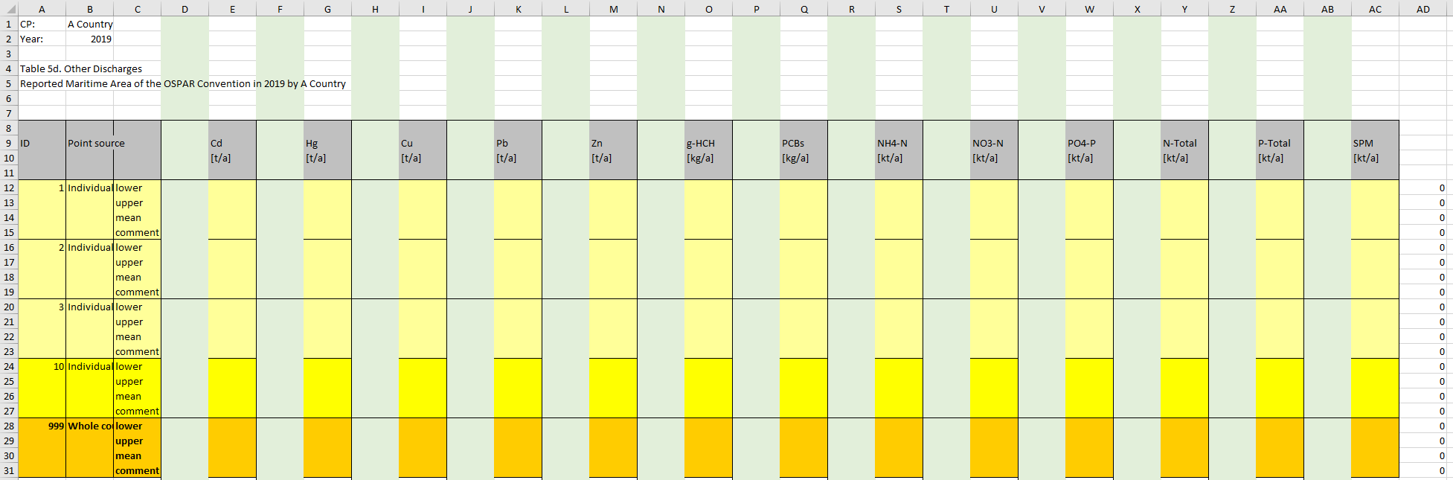
Table 5e Total direct discharges | 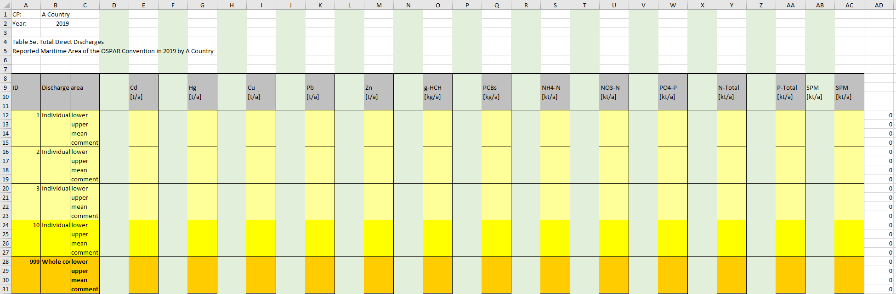

- Table 6 Data reporting sheets for riverine (monitored and unmonitored) inputs
Table 6a Monitored rivers | 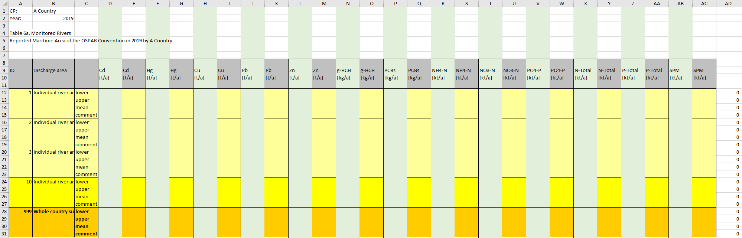
Table 6b Unmonitored rivers | 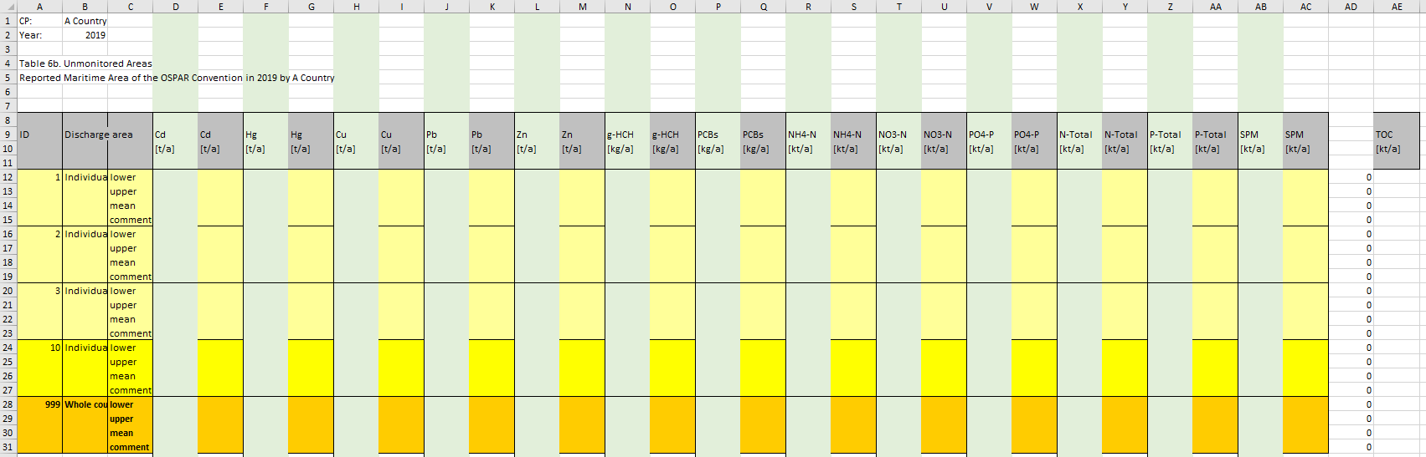
Table 6c Total riverine inputs (monitored and unmonitored) | 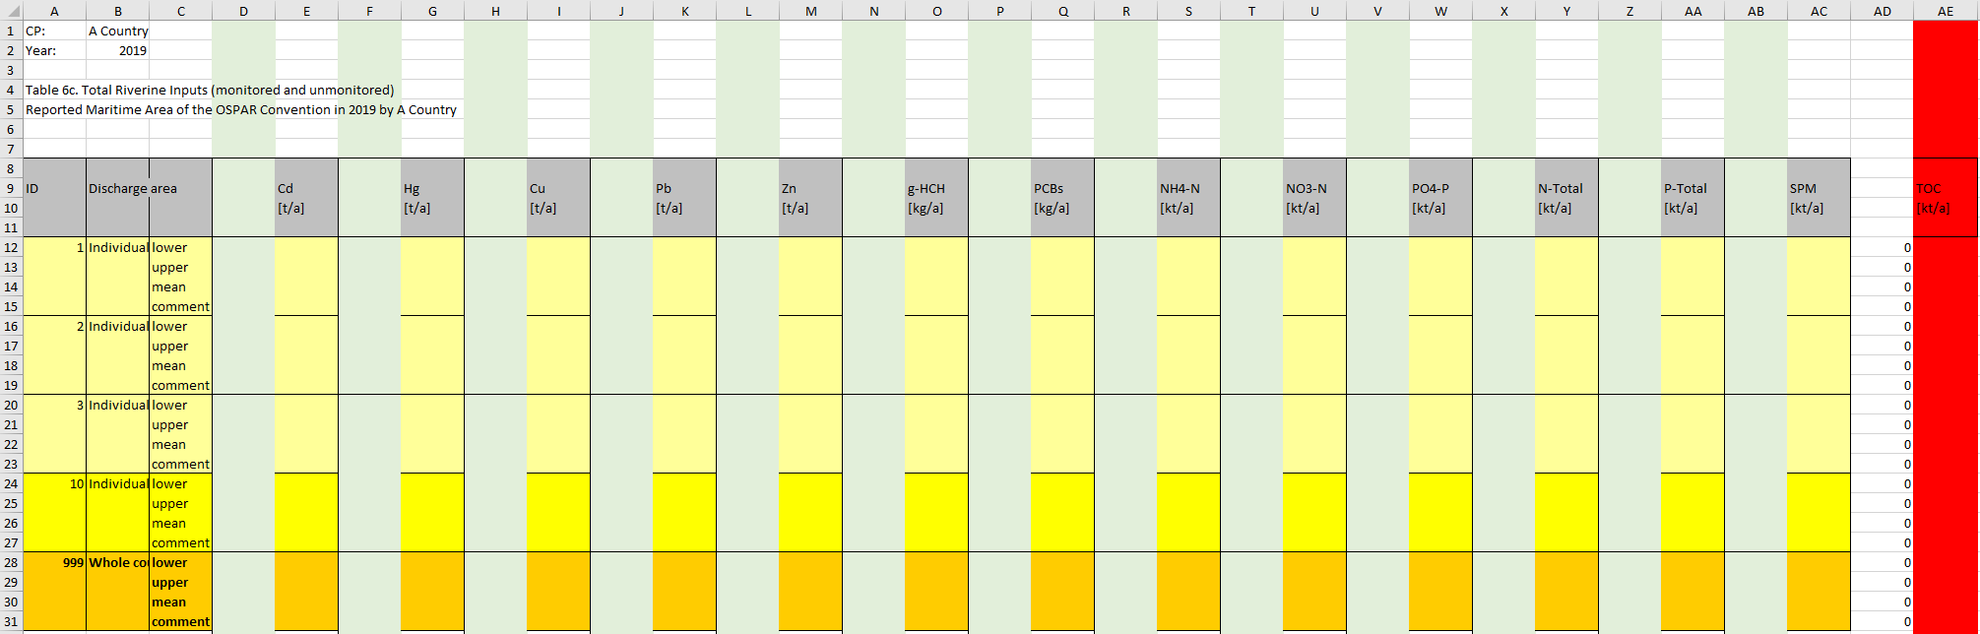

- Table 7 Reporting sheet for concentration data
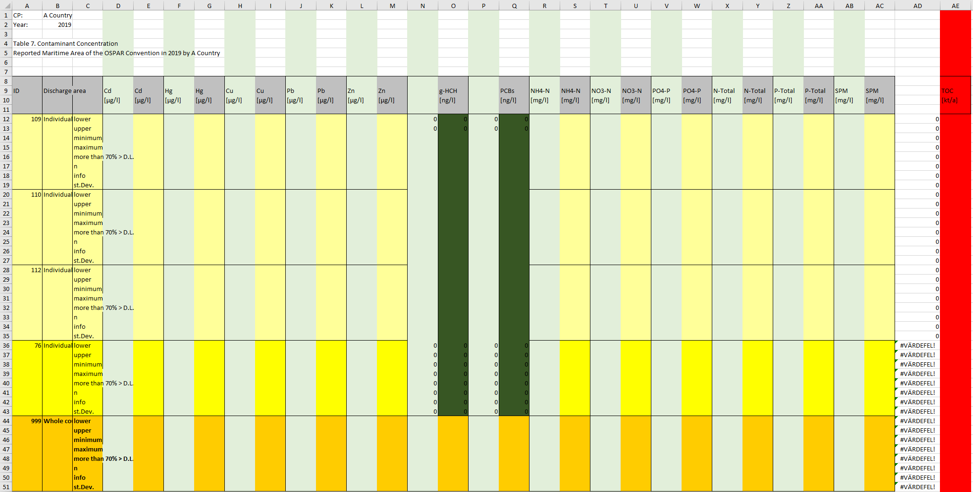
- Table 9 Reporting sheet for flow data
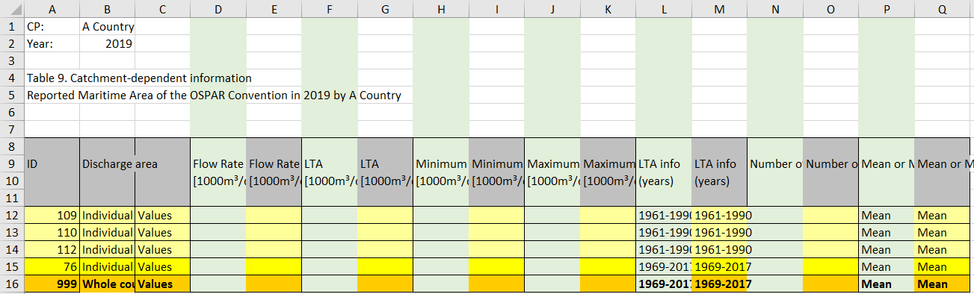

OSPAR Contracting Parties are Belgium, Denmark, the European Union, Finland, France, Germany, Iceland, Ireland, Luxembourg, Netherlands, Norway, Portugal, Spain, Sweden, Switzerland, United Kingdom
https://www.ospar.org/convention/text
https://www.ospar.org/documents?d=34012
OSPAR Agreement 14-04, Riverine Inputs and Direct Discharges Monitoring Programme (RID) applicable from 1 January 2015. Adopted: 2014, Cascais, Agreement 2014-04, https://www.ospar.org/documents?d=33689
https://qsr2010.ospar.org/
https://gitlab.nibio.no/Csilla/rid_database
https://www.ogc.org/
https://odims.ospar.org/

