Last updated April 2025

North Sea Manual on Maritime Pollution Offences

Part I

Revisions 1
Part I: Introduction and Background 2
Chapter 1: Introduction 2
Section 1.1: Purpose of this Manual 2
Section 1.2: Development of this Manual 3
Chapter 2: Oil Pollution and its Significance 4
Section 2.1: Oil spills 4
Causes 4
Consequences of oil spills at sea 4
Section 2.2: Behaviour of spilled oil 5
Section 2.3: Operational strategies 7

Part I: Introduction and Background
The purpose of this manual is to support the detection of maritime pollution offences, the collection of evidence about such offences and the imposition of penalties on those responsible for them, thereby helping to deter further offences and improving the marine environment. As background, this section also sets out the effects of marine oil pollution.
This manual was jointly developed by the North Sea Network of Investigators and Prosecutors (NSN), a body associated with the OSPAR Commission, and the Agreement for cooperation in dealing with pollution of the North Sea by oil and other harmful substances, 1983 (Bonn Agreement). This manual is a living document and will continuously be updated and further developed by NSN and the Bonn Agreement in order to take into account legal, political and technical developments in the field of maritime oil pollution offences.

Chapter 1: Introduction
This chapter sets out the aims of this manual and the way in which it has been developed

Section 1.1: Purpose of this Manual
1.1 It is more than forty years since the international community first adopted international rules and standards to protect the marine environment against pollution from ships. This was achieved by the 1973 International Convention on the Prevention of Pollution from Ships, which was completed and adjusted to ensure entry into force by the 1978 Protocol to it - the two instruments together being known as MARPOL. Since then the international rules and standards set out in MARPOL have been extended, improved and strengthened on many occasions.
1.2 But the best of legislation will have no impact on the real world unless it is implemented and enforced. There is still much room for improvement in the implementation and enforcement of MARPOL. This manual is intended to assist in this process in the North Sea Area – the waters covered by the Bonn Agreement. It is also hoped that the experience described in the Manual will be helpful to other States.
1.3 The Manual is addressed, in the first place, to the national enforcement agencies concerned with implementing international rules and standards against oil pollution from ships, and the national legislation applying them. To achieve their purpose, this legislation must be effectively enforced. It is therefore essential that ships which contravene the legislation by illegally discharging materials are detected, prosecuted and convicted. Shipping is an international business and the North Sea Area covers some of the busiest shipping routes in the world. A pollution incident may affect more than one country. For example, a vessel may discharge an illegal quantity of oil in the exclusive economic zone (or equivalent area of jurisdiction) of one State whilst en-route between ports in two other countries. Cooperation between neighbouring States is therefore essential, and effective cooperation requires a common understanding of what is involved. This manual therefore aims to set out a common understanding of the impacts of oil pollution, how evidence of maritime pollution offences can be gathered, and the reliability of the methods used.
1.4 The Manual is also addressed to those involved in the processes of bringing offenders to justice - prosecutors, defence lawyers and magistrates and judges. For them, it is intended to provide an internationally agreed statement of the significance of maritime pollution offences and of good practice in assembling, presenting and evaluating evidence on such offences. Since violations of the regulations on maritime pollution offences can cause serious environmental damage, and lead to heavy costs for combating the oil spills and clearing up the damage, it is essential that appropriate action is taken against the violators. This Manual is intended to support such action.

Section 1.2: Development of this Manual
1.5 At the third International Conference on the Protection of the North Sea in the Hague in 1990, the Ministers and EC Commissioner decided that common actions should be taken at national and international level in order to improve the effectiveness of prosecution for violations of the international rules and standards established by MARPOL, and the associated collection of evidence.
1.6 As a first step, Ministers invited the Contracting Parties to the Bonn Agreement to produce a Manual explaining the systems of airborne surveillance and other methods used for identifying offenders and for obtaining evidence. The Manual "Oil Pollution At Sea - Securing Evidence on Discharges from Ships" was published in 1993 by the Bonn Agreement and was disseminated worldwide through the International Maritime Organization. The Manual was addressed to authorities in charge of detecting violations, police officers, prosecutors, defence lawyers and courts in order to explain how evidence can be gathered and to indicate the reliability of the methods used. It was intended to facilitate the common understanding of the methods used for those who are not familiar with the technicalities.
1.7 Taking into account the progress made in the establishment of exclusive economic zones (EEZ), the Ministers at the Fourth International Conference for the Protection of the North Sea in Esbjerg 1993 agreed as a second step to develop common procedures with the aim of facilitating, in a harmonised way, the rendering of assistance and the admissibility of different forms of evidence and co-operation between the North Sea States. To achieve this facilitation, the Contracting Parties to the Bonn Agreement agreed to develop guidelines for personnel engaged in securing or gathering evidence as a complement to the original Manual. These guidelines were published in 1999 as the Manual "Oil Pollution at Sea - Part 2: Effective Prosecution of Offenders - Guidelines on International Co-operation".
1.8 In 2002, the Fifth North Sea Conference, held in Bergen, Norway, returned to the issue. Although the progress that had been made was recognised, the Ministers recognised that further action was needed, both internationally and nationally, in order to prevent pollution from shipping activities in the North Sea. Accordingly, they agreed to take initiatives to create a network of investigators and prosecutors to improve understanding and cooperation in the different stages of the enforcement process, and urged all North Sea States to ensure that the investigators, prosecutors and others involved in the enforcement process in their systems are aware of each other's requirements.
1.9 With Sweden as host, the North Sea Network of Investigators and Prosecutors (the North Sea Network) was established in 2002, supported by the OSPAR Secretariat. Their annual meetings have served to improve mutual understanding and cooperation. The Contracting Parties to the Bonn Agreement and the North Sea Network have collaborated to integrate, revise and update the two parts of the Manual "Oil Pollution at Sea" into this Manual.

Chapter 2: Oil Pollution and its Significance
This chapter provides general information on oil spills, their behaviour and effects, including an explanation of the weathering process. It also outlines the operational strategy for dealing with oil pollution at sea and on the coasts.

Section 2.1: Oil spills

Causes
2.1 The North Sea contains some of the busiest shipping routes in the world: nearly 600,000 ship movements a year take place into, and out of, the 50 main ports around the North Sea. On average, more than 400 ships a day pass through the Straits of Dover and, at the same time, 600 ships cross those straits, including 200 ferries.
2.2 This shipping activity is rapidly increasing: container traffic increased by 120% in the 1990s, and is still increasing. Bulk carriage of oil and chemicals is likewise expected to continue increasing, particularly from the expected development of oil traffic from the Siberian pipeline terminal at Murmansk which will result in substantial traffic to Rotterdam and through the western part of the North Sea Area to the rest of the world.
2.3 All this activity gives rise to spills of oil. Some of these spills are the result of maritime accidents: collisions or shipwrecks which lead to the spilling of the oil on board the vessels involved, either fuel oil (bunkers) or lubricating oil for the ship itself or oil cargoes. Many of these maritime accidents result in acute pollution – the “black tides” (marées noires) as they are called in French. These acute incidents can result in massive oil spills: in 1993, the wreck of the Braer resulted in the release of 86 300 tonnes of oil.
2.4 At the same time, discharges of oil and oily wastes as part of the operations of the vessels often result in chronic oil pollution. Aerial observations in the North Sea Area detect oil spills resulting from such discharges in over 130 cases a year. And these are only the cases that are detected.
2.5 The offshore oil and gas industry also produces oil spills from offshore installations. In 2013, 15 spills of more than 1 tonne of oil were reported as well as 469 spills below 1 tonne resulting in a total of 135 tonnes of oil spilled. In addition, large quantities of oil are discharged in produced water (the water produced from oil and gas wells alongside the oil and gas). This is usually at low concentrations (in most cases below 30 parts per million, and rarely above 40 parts per million). Nevertheless, in 2013, 3 951 tonnes were discharged in this way.

Consequences of oil spills at sea
2.6 Oil spilled at sea threatens the environment. Resources at risk include ecologically important areas, fisheries, areas of outstanding natural beauty, industrial installations and areas used for recreation and tourism. An oil spill can present an immediate hazard by causing damage and death to birds and marine mammals and by exerting a toxic stress on subsurface organisms. Oil dissolved in the water is quickly dispersed to concentrations below the acute toxicity level but it can be taken up by organisms and affect their physiology, behaviour, reproductive potential and survival. Oil may also be transferred to the sediment, where it might persist for many years and impact on organisms on and in the sea bed (benthos).
2.7 Once oil arrives in inshore waters and starts to come ashore, its potential to cause damage is much wider. Should oil be spilt or drift into an estuary it can pose particular problems due to the shallow waters, high levels of sediment in the water (which can absorb the oil) and the presence of vulnerable mud flats and salt marshes. In archipelago and wetland areas the spill, as a rule, leads to very high costs for combating the clean-up measures.
2.8 Oil on tidal flats leading to the death of a large number of benthic organisms and to habitat deterioration can result in both short and long term damage. The reduction in the quantity of food (benthic organisms) and changes in the food composition may have effects on the size of the population of fish, shellfish, birds and seals. For each group of organisms there are different danger periods: the spring season for breeding birds and fish larvae, summer for benthic organisms and seals and winter for migratory or wintering birds.
2.9 Oil pollution – particularly chronic oil pollution – is a significant cause of death among seabirds. The measures that have been taken to reduce it have been successful in the North Sea – the proportion of dead guillemots polluted by oil has dropped by 50% since surveys started in the 1970s. Nevertheless, in the areas of the North Sea near the major shipping routes, the proportions of deaths of guillemots where oil pollution is a cause, or a contributory cause, is still over 10%.

Section 2.2: Behaviour of spilled oil
Development and behaviour of oil slicks
2.10 The behaviour of spilt oil is illustrated in figure 2.1.
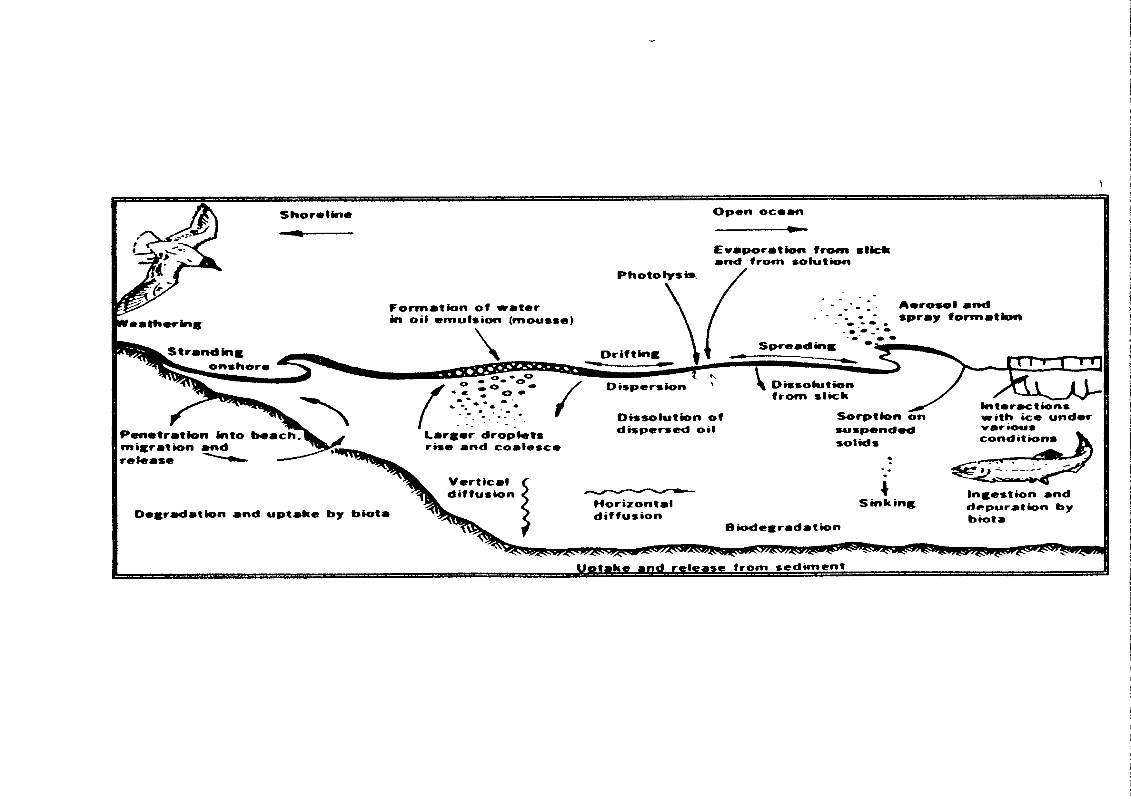
Figure 2.1: Processes taking place after an oil spill
2.11 Oil spilt on the sea surface will immediately spread. The oil will, due to its physical and chemical properties as well as external conditions, spread in an unpredictable way, resulting in an inhomogeneous spill (slick) consisting of thick patches and lumps interspersed with a thin oil film. The shape of the spill is largely determined by wind, waves and current.
2.12 The oil slick will then drift. The way an oil slick drifts at sea is determined by the following environmental factors:
a. sea current speed and direction (including tides);
b. wind speed and direction;
c. wave pattern.
The current moves the spill with the water. In the absence of wind the oil normally moves at the same speed and in the same direction as the current. However, the movement of the oil is also affected by the wind, at a speed estimated as a few percent of the wind speed.
2.13 Waves are less important as they do not induce any considerable net movement of the oil spill. They are more important for the spreading and weathering processes.
2.14 Oil spilt into the sea will be affected by a number of weathering processes. As the oil spreads, the evaporation rate increases but the speed and extent of evaporation will vary considerably depending upon its composition. Light oils, like gasoline or light fuel oil, evaporate very quickly (50% within a few hours) while heavy oils evaporate more slowly. Evaporation is also affected by wind speed and temperature, the higher the wind speed and temperature the faster the evaporation.
2.15 The process of vertical dispersion and re-dispersion plays an important part in the dissolution of oil into the sea. In rough weather a significant proportion of the oil on the surface of the sea will be dispersed into the water column, mostly due to the breaking of waves. The dispersed oil droplets will tend to resurface or be re-dispersed due to buoyancy forces: large droplets will quickly resurface, whereas smaller droplets can be transported by the water current far away from the point of spillage and remain dispersed for weeks. When the oil attaches to or forms particles with a density exceeding that of water it may sink to the bottom of the sea in a process called sedimentation.
2.16 A further important weathering process is the emulsification of the slick, for example, the incorporation of water into the oil, thus changing the properties of the oil and the amount present on the sea surface. The water content of these emulsions, which are often known as chocolate mousse, can reach a level of up to 80-90%. Wind conditions and the viscosity of the oil are the most important factors governing the formation of emulsions which can result in an oil spill volume double that of the spilt volume five days after the spillage.
2.17 The sun’s rays change the properties of oil on the sea surface by means of photo-oxidation. This increases the spreading and stabilises the formation of emulsion.
Biodegradation
2.18 Oil spills are also subject to biodegradation, an extremely slow process but one which is important in the long run. However not all components of the oil can be degraded by micro-organisms.
2.19 An illustration of the time span and relative importance of the various processes described above is shown in figure 2.2.

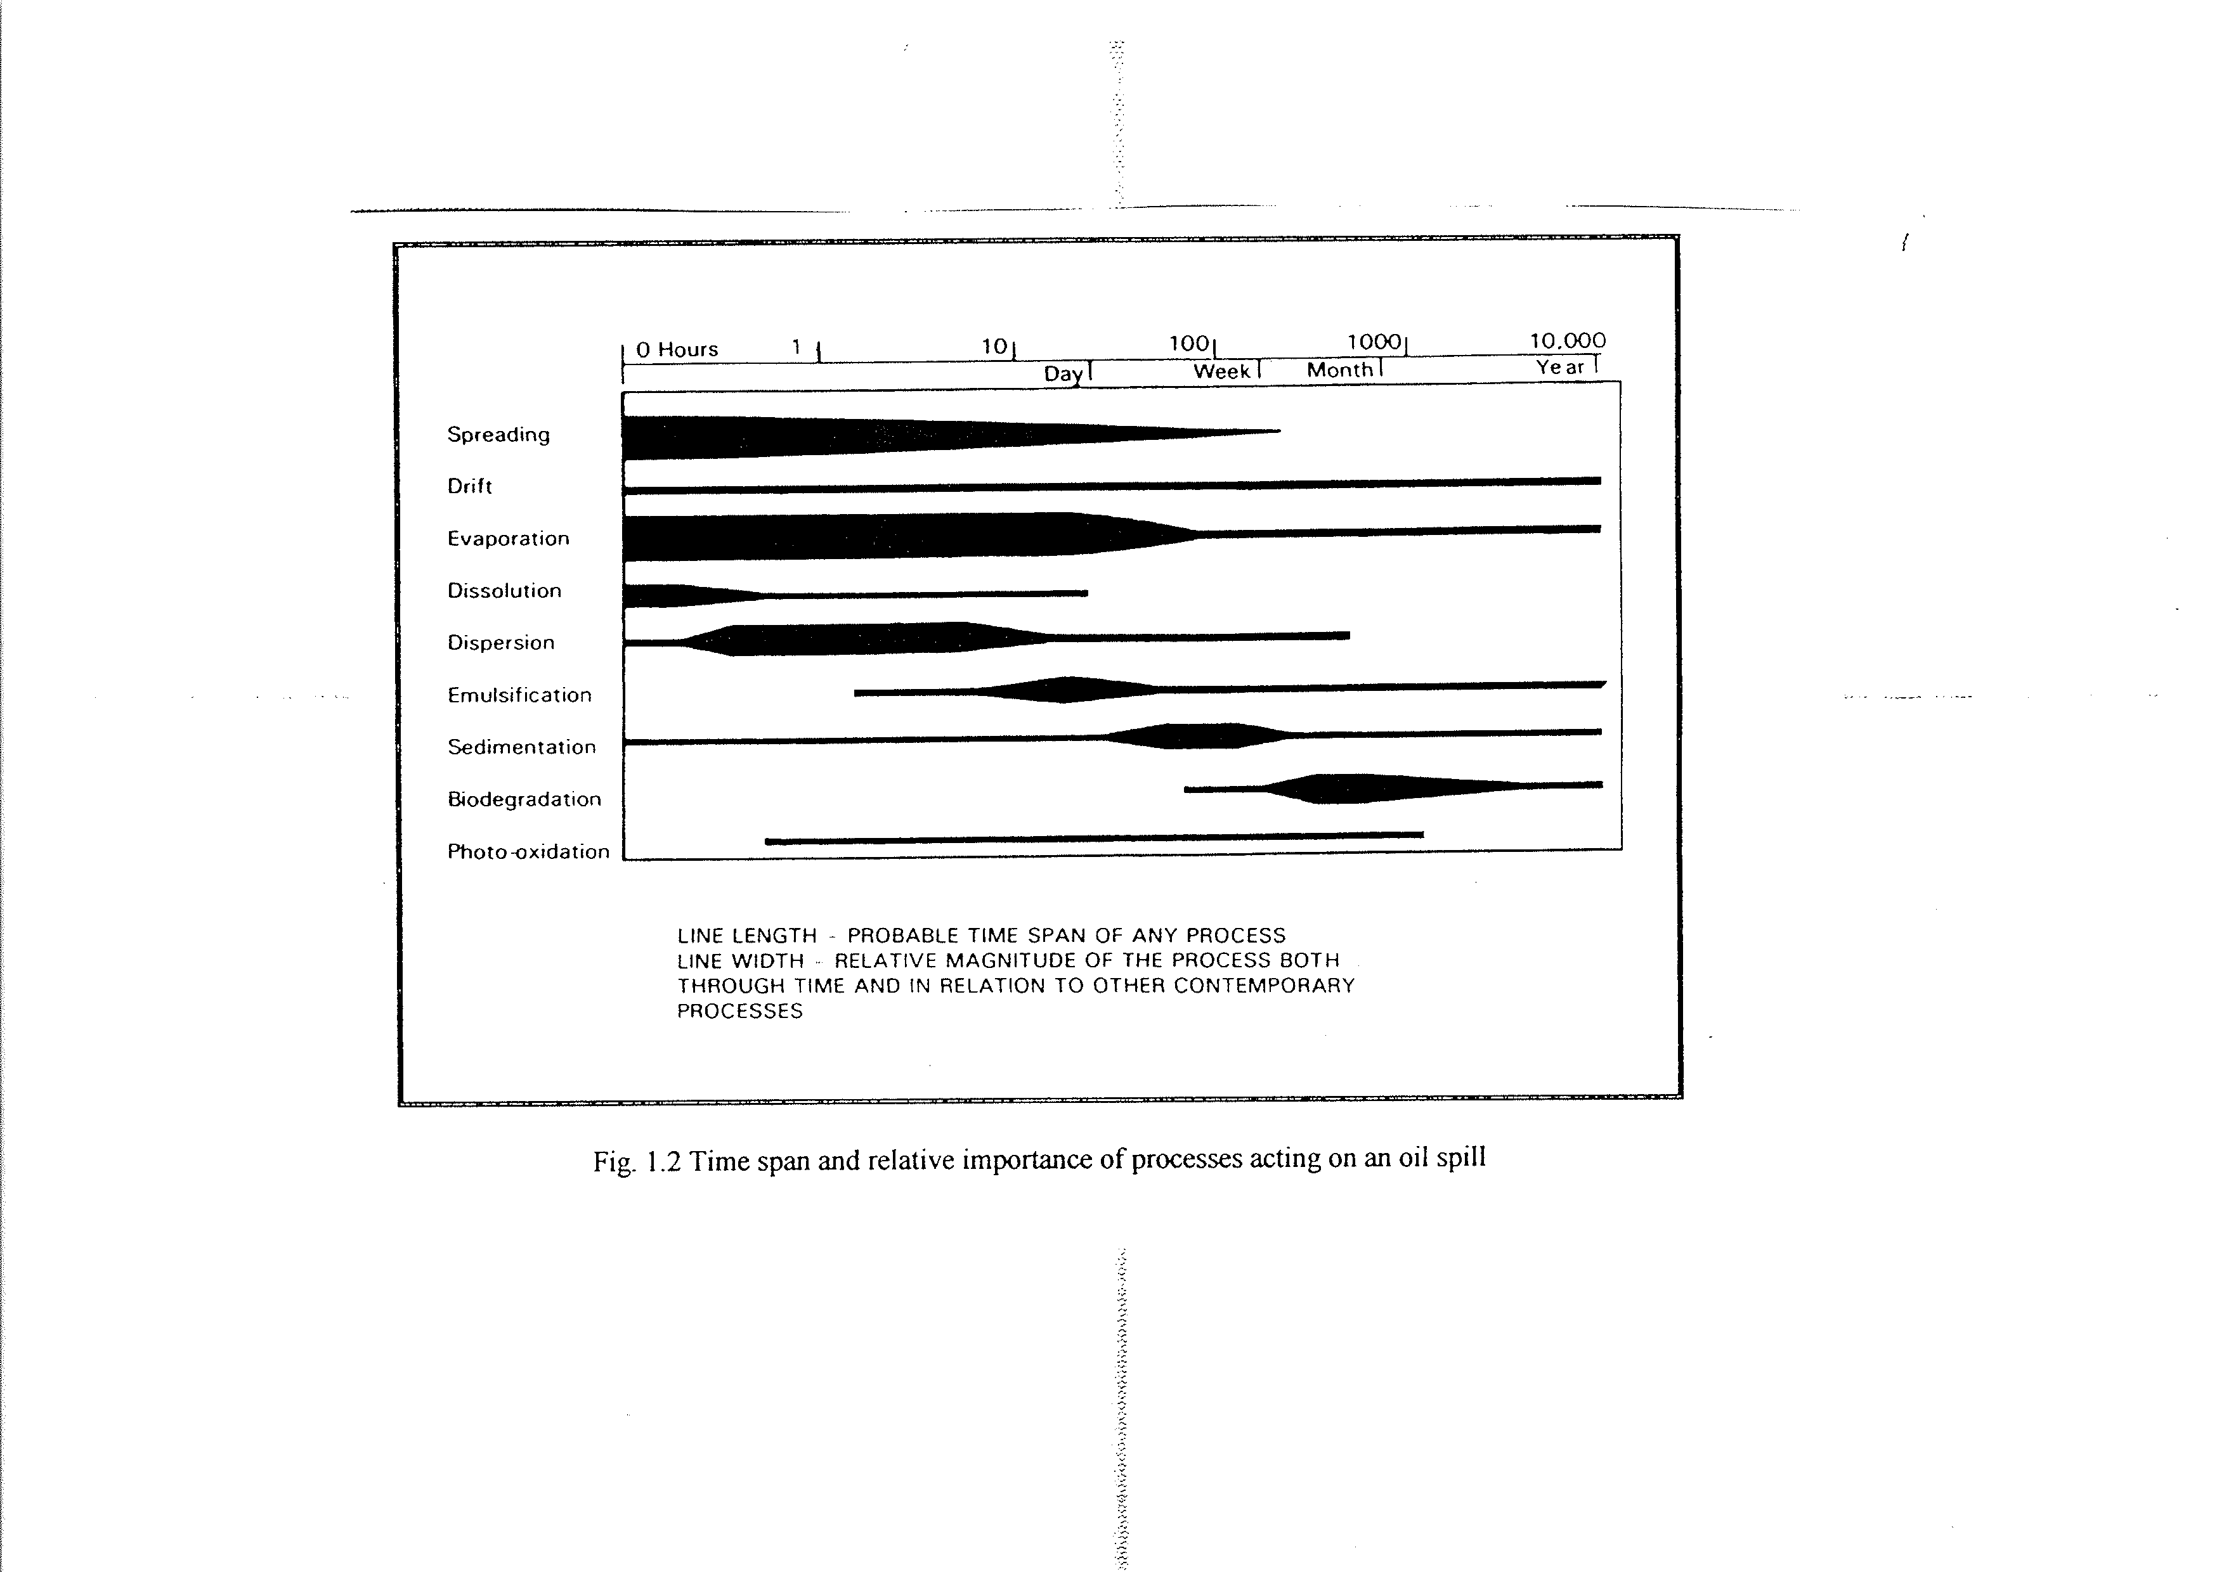
Figure 2.2: Time span and relative importance of processes acting on an oil spill

Section 2.3: Operational strategies
2.20 The operational strategy to deal with oil pollution at sea has two components:
a. a surveillance strategy to detect and identify spillages, document the discharge and identify the polluter;
b. a contingency plan to deal with the spilt oil: this covers determination of responsibilities, lines of command, lines of communication, location and content of stocks of equipment and available combating options. The main issues to be specified in the contingency plan are specified in the International Convention on Oil Pollution Preparedness and Response (OPRC).
2.21 The response action to minimize damage to the environment and reduce costs as much as possible is beyond the scope of this Manual.
2.22 As part of the surveillance strategy, evidence is gathered either to establish the basis for civil liability or to start legal proceedings against a violator of the MARPOL rules described in Chapter 3. This may involve a number of techniques such as:
a. inspection of the suspected pollution source;
b. visual observation of the spill;
c. remote sensing (aerial surveillance and satellite images);
d. spreading and drift models (back-tracking);
e. sampling and analysis.

The North Sea Area covers the North Sea proper (south of latitude 63° 38 10.68N ) and the English Channel to a line 50 nautical miles west of a line from Ushant to the Isles of Scilly; and the waters subject to the jurisdiction of Ireland together with adjoining UK and Norwegian waters.

