OSPAR Monitoring Strategy for Ambient Underwater Noise

(Agreement 2015-05)

Contents

OSPAR Monitoring Strategy for Ambient Underwater Noise 3
1. Introduction 3
2. MSFD Descriptor 11 3
3. Principles 4
4. Definitions 4
4.1 “Sound”, “noise” and “ambient noise” 4
4.2 Category A and Category B measurements 5
4.3 Summary of definitions 6
5. Joint monitoring strategy 6
5.1 Modelling and Measurement (pros and cons) 6
5.2 approach 7
5.2.1 Step 1: A priori modelling 7
5.2.2 Step 2: Measurements for validation 8
5.2.3 Step 3: Iteratively combine modelling and measurement 8
5.2.4 Step 4: Mature results 9
6. Need for international standardization 10
7. Considerations of ceNtre frequencies other than 63 Hz and 125 Hz 10
8. averaging methods 13
9. Summary 14
References 15

Acknowledgement:
This document was prepared by ARCADIS Nederland BV for Rijkswaterstaat WVL.
Authors: R.C. Snoek (ARCADIS), M.A. Ainslie (TNO), M.K. Prior (TNO), Eline van Onselen (ARCADIS)

OSPAR Monitoring Strategy for Ambient Underwater Noise

1. Introduction
In 2008 the European Commission approved the Marine Strategy Framework Directive (MSFD: 2008/56/EC), requiring all EU Member States (MS), to reach or maintain Good Environmental Status (GES) by 2020. GES is described in eleven descriptors and all the MS must set criteria and methodological standards for each descriptor in their marine waters. Descriptor 11 focuses on the energy in the marine environment, including underwater noise.
The implementation of the MSFD was included in the North East Atlantic Environment Strategy adopted by OSPAR in 2010. Underwater noise is addressed in the thematic section on Biological Diversity and Ecosystems where the aim is to “endeavour to keep the introduction of energy, including underwater noise, at levels that do not adversely affect the marine environment in the OSPAR maritime area”;
Sounds are omnipresent in the underwater environment, and can be produced by natural and anthropogenic sources. In comparison to air, water supports propagation of sound better and the attenuation is less, resulting in sound travelling over longer distances and faster in water than in air. Natural sound sources include breaking waves, splashes from raindrops and lightning, the sound produced by marine fauna and wave interactions (TNO, 2009).
Anthropogenic activities such as shipping, military activities, construction work and oil and gas exploitation lead to an increase of underwater sound sources in areas where natural sound sources would typically be the only sources available. There is an increasing concern about the possibility of negative effects of anthropogenic underwater noise on the life of marine fauna. Behaviour such as foraging, migration and reproduction could be disrupted. In some cases hearing impairment or physical damage can occur in species such as fish or marine mammals, which may in turn affect the population.
Descriptor 11 describes two types of underwater sound, divided into two indicators: loud, low and mid frequency impulsive sounds (11.1.1) and continuous low frequency sound (11.2.1). This study focuses on the second, widely referred to as “ambient noise”. The first indicator focusses on the registration of impulsive noise and – although not discussed in this report – will play an important role in providing data with potential for the monitoring of ambient noise.
Ambient noise is caused by both natural and anthropogenic sources. Current ambient noise levels in European marine waters are largely unknown. An increasing trend in ambient noise levels might increase the pressure on marine ecosystems.
This strategy elaborates a proposed approach for the monitoring of underwater ambient noise, using sound maps generated from a combination of models and measurements.

2. MSFD Descriptor 11
The Marine Strategy Framework Directive Descriptor 11 on the introduction of energy, including underwater noise is described as:
Introduction of energy, including underwater noise, is at levels that do not adversely affect the marine environment
It also describes two indicators for Descriptor 11, of which the second (Indicator 11.2.1, for continuous low frequency sound) reads:
Trends in the ambient noise level within the 1/3 octave bands 63 and 125 Hz (centre frequency) (re 1μΡa RMS; average noise level in these octave bands over a year) measured by observation stations and/or with the use of models if appropriate (11.2.1).
Indicator 11.2.1 is interpreted by the Technical Sub-Group on Noise (TSG Noise) (Dekeling et al., 2014) as:
Indicator 11.2.1: Trends in the annual average of the squared sound pressure associated with ambient noise in each of two third octave bands, one centred at 63 Hz and the other at 125 Hz, expressed as a level in decibels, in units of dB re 1 μPa, either measured directly at observation stations, or inferred from a model used to interpolate between or extrapolate from measurements at observation stations (Van der Graaf, 2012).
The aim of this strategy is to facilitate monitoring of Indicator 11.2.1 which was adopted by OSPAR as a common indicator. The strategy outlines a set of agreed principles, the main terminology used and the monitoring approach.

3. Principles
The meeting of OSPAR’s Environmental Impact of Human Activities Committee (EIHA) in April 2015, agreed the principle of a joint monitoring strategy for ambient noise, and that the monitoring strategy should then be realised in the form of joint monitoring programmes covering the appropriate spatial scale. The strategy supports intra- and inter-regional comparisons, and would be based primarily on model predictions in the form of sound maps, supported by measurements. Finally, it was agreed in principle to follow:
- TSG Noise Guidance Document (Dekeling et al., adopted as OSPAR Agreement 2014-08);
- Use of Sound Maps for monitoring GES: Examples and way ahead (Ainslie, 2014);
- Technical Group on Noise (TG Noise) Guidance (TG Noise, 2014);
- BIAS (Baltic Sea Information on the Acoustic Seascape) project measurement document and lessons learned (Verfuß et al., 2014); and
- that the joint monitoring programme would be based on international consensus and efficient use of each Contracting Party’s expertise.

4. Definitions
Where applicable, underwater acoustical terminology used in the monitoring strategy follows ISO/DIS 18405, as advised by TG Noise adopted in OSPAR Recommendation 2014-08.

4.1 “Sound”, “noise” and “ambient noise”
It is usual to use the word “noise” to mean “unwanted sound”. The EU Technical Sub Group on Underwater noise defines “noise” as sound for which “adverse effects are specifically described” (Figure 1).
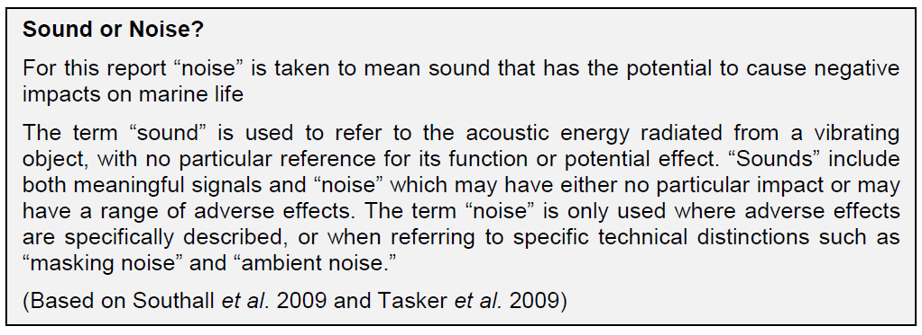
Figure 1 Sound or Noise text box from (van de Graaf, 2012)
This general rule is followed in the present strategy. An exception to this general rule is the term “ambient noise”, defined by EU TSG Noise as:
ambient noise: For a specified signal, all sound in the absence of that signal except that resulting from the deployment, operation or recovery of the recording equipment and its associated platform. (This definition is accompanied by the explanatory note “If no signal is specified, all sound except that resulting from the deployment, operation or recovery of the recording equipment and its associated platform.”)
and by ISO/DIS 18405 as
ambient noise: for a specified sonar signal, all sound in the absence of that signal, except acoustic self-noise and reverberation (This definition is accompanied by the explanatory note “If no signal is specified, ambient noise is all sound except acoustic self-noise and reverberation.”)
In the present (MSFD) context there is no specified signal and no reverberation, so both these definitions amount to
ambient noise: all sound except the sound resulting from the deployment, operation, or recovery of a receiver, and its associated platform
This is the definition adopted here. This definition contains an inherent contradiction because “ambient noise” includes some sound that is not “noise”. We resolve this contradiction by accepting that in the context of the MSFD, the term “ambient noise” is not a subset of “noise”.

4.2 Category A and Category B measurements
In Dekeling et al. (2014) a distinction is made in category A and category B measurements. Based on this, the following objectives are defined for both categories of measurements:
Category A measurements: Objective of Category A measurements is to collect information on ambient noise levels at a location, for the validation of ambient noise predictions.
Category B measurements: Objective of Category B measurements is to collect information on specific sources to reduce the uncertainty in source levels used as input in modelling.

4.3 Summary of definitions
The acoustical terminology used follows ISO/DIS 18405 throughout this strategy. In addition, the terms “noise”, “ambient noise”, “ambient noise monitoring”, “acoustic basin” and “ambient noise map” are used in this strategy with the following specific meanings:
- Noise: unwanted sound; sound for which adverse effects are specifically described
- Ambient noise: all sound except the sound resulting from the deployment, operation, or recovery of a receiver, and its associated platform
- Ambient noise monitoring: combination of measurement and (numerical) modelling leading to an assessment of ambient noise
- Acoustic basin (as proposed in the summary record of the meeting of OSPAR’s Intersessional Correspondence Group on Noise (ICG-Noise) 2014): geographical area which has logical boundaries, typically based on bathymetry (at least at some sides), where it is useful to combine data from sources within that area to determine the sound field, and where sound sources from outside that area are of lesser relevance.
- Ambient noise map: geographical representation of depth-averaged ambient noise, for a specified time window and frequency range.

5. joint monitoring strategy

5.1 Modelling and Measurement (pros and cons)
Use of numerical models is cost-effective. Computers are getting faster and cheaper, and the models can be operated in a controlled environment, thus providing insight into ‘driving forces’. As soon as they are verified calibrated and validated, they have the potential to answer “why?” questions as well as “what?” questions. On the other hand the models require accurate input data that are not always available such as the ocean environment, sound sources and weather information. Models are not always correct, if they are used, for example, outside their intended regime of applicability or with insufficiently reliable input data. Modelling results in rapid answers, good (apparent) spatial and temporal coverage, and insight into the relative contributions of important sources.
If equipment is calibrated and maintained (and survives), measurements can be accurate. They provide a direct quantification of the parameter of interest. On the downside, measurements are specific to the time and place where the measurements took place (they provide a number but no context), and the cost of measurements (for example, purchase, calibration, installation, maintenance, replacement) can be high.
Modelling on its own is unsuitable because without a measurement there is no way of verifying the accuracy of the model predictions. Measurements on their own are unsuitable because without a validated model to provide insight, there is no way of telling whether the data from the measurement stations adequately capture the important spatial and temporal features of the ocean sound field. From Dekeling et al. (2014):
TSG Noise concludes that the combined use of measurements and models (and possibly sound maps) is the best way for Member States to ascertain levels and trends of ambient noise in the relevant frequency bands. Member States should be careful to balance modelling with appropriate measurements.
So error maps must be computed and proposed with the model results. In other words, what is needed is a combination of both measurements and modelling. Measurers use modelling at the planning stage and during analysis. Modellers use measurements during model development and for model validation. So in practice one always has a mixture. The real question we should be asking is “What model-measurement mixture strategy should be used?” In this strategy models’ indicates specific numeric models.

5.2 approach
The approach for monitoring of underwater sound uses sound maps, generated from a combination of models and measurements. This approach is expected to be cost-effective, to have sufficient accuracy and to be fit for purpose (Summary Record, ICG-Noise, 2014).
Models should be used to place measurement equipment, and to extrapolate from measurements to generate estimates for entire region. A four-step process has been adopted (Ainslie et al 2014):
- A priori modelling;
- Measurements for validation;
- Iteratively combine modelling and measurement;
- Mature results for Indicator 11.2.1.
This approach requires the existence of internationally agreed procedures for modelling and for measurements, and also for converting the model output into an agreed sound map with the help of the measurements. Ideally these procedures would be in the form of International Standards. However the development of standards is only just starting, therefore there will be a delay of a few years before they are completed, and we need to start monitoring now. This means that a pragmatic choice needs to be made. The BIAS measurement procedure has been adopted as a starting point, as advised by TG Noise. At the same time it makes sense to start the process towards ISO standardisation without delay.
A pre-requisite for the development of any of the above procedures is the adoption of a clear and unambiguous language – a dictionary of underwater acoustical terminology. Therefore the ISO/DIS 18405 (available from April 2015) has been adopted, as advised by TG Noise.

5.2.1 Step 1: A priori modelling
Step 1 involves the use of modelling to predict the spatial variability of annually averaged anthropogenic and natural sound. This modelling provides an initial estimate of the sound levels and at the same time leads to a cost-effective measurement programme. It identifies how many measurement stations are needed and where they should be placed. As a first step it is proposed to evaluate the annual average of the squared sound pressure, as required by Indicator 11.2.1. The output of Step 1 is one or more predicted ambient noise maps that are suitable for comparison with the measurements of Step 2.
Indicator 11.2.1 was selected to be representative for shipping. Information about shipping distributions will be needed, e.g. from AIS (Automatic Identification System). Initially, shipping source levels can be used from Wales & Heitmeyer (2002), with a corresponding source depth from Gray & Greely (1980), until updated source models for shipping become available from initiatives like the European Research projects SONIC (http://www.sonic-project.eu/) and AQUO (http://www.aquo.eu/).
In some locations the sound at MSFD frequencies is likely to be dominated not by ships but by other man-made sources (airguns, pile driving, explosions) or natural sources (especially wind and possibly lightning).
Inputs needed for modelling include environmental data (surface, volume, seabed) and source characterisation (minimum info needed is geographical distribution, source level spectrum and source depth).
Environmental input information needed includes:
- Volume: Ocean temperature/salinity/sound-speed (MyOcean, World Ocean Atlas…);
- seabed properties: Bathymetry (for example, emodnet, etopo, gebco) Seabed properties (National hydrographic services, Global database (US));
- sea surface properties: Surface state (wind speed and/or wave height), MyOcean, Met. Offices.

5.2.2 Step 2: Measurements for validation
The purpose of Step 2 is to make measurements in order to establish information on the ambient noise in a location and to quantify the error in the Step 1 estimate of ambient noise level, so-called “Category A measurements” (Dekeling et al., 2014). The following criteria are applicable to Step 2:

- At least one measurement station per acoustic basin;
- While not necessarily continuous, the measurements should cover several seasons;
- Locations ~5 km from shipping lanes (TSG Noise) to avoid dominance of a single source; allows sensing of field from diverse, distant sources;
- Sensors close to seabed;
- Measure auxiliary data where possible: Wind speed, temperature (air and water), conductivity, pH.
The Step 2 measurements should be analysed to quantify the error made in Step 1 at the measurement locations. The purpose is to measure ambient noise, in a way suitable for comparison with predictions, in order to permit an assessment of the strengths and weaknesses of modelling. The purpose is not to characterise individual sources of sound.
The output of Step 2 is a measurement suitable for comparison with the predicted ambient noise map(s) of Step 1.

5.2.3 Step 3: Iteratively combine modelling and measurement
Once Steps 1 and 2 are complete their results can be compared and combined in Step 3. In fact Step 3 is an iterative process that successively compares the Category A measurements with model predictions, improves or corrects the model or its inputs as needed and then repeats the comparisons. Continuing Category A measurements are therefore needed throughout Step 3 (and Step 4), but what also will be needed are measurements that improve knowledge of the sources and of the propagation medium.
It is considered likely that shipping and (in selected locations) seismic surveys, pile driving and explosions will contribute significantly to the ambient noise maps, which makes it likely that improved knowledge of the associated sources will be needed in Step 3. It is worth thinking early on in the development of joint monitoring about how this improved knowledge can be obtained.
- Identify need for further measurements
- Reduce uncertainty in key parameters (e.g. source level)
- Shipping categories for similar source level
- Temporal changes in environmental properties
- Source models other than shipping
- Direct calibration
- Propagation loss
- Source levels
- Environmental properties
- Seabed, water properties, etc.
In addition to the Category A measurements mentioned above, EU TSG Noise guidance describes Category B measurements intended to provide information about sound sources and propagation conditions. Step 3 is likely to involve both Category A and Category B measurements.
Category B measurements for ship source level requires measurements dominated by single sources during transit and results in source levels for individual vessels as identified by AIS. Stations should be ~300m from the edge of a shipping lane (TSG noise).
There are several standards in development for measuring the radiated noise level (RNL) of ships in deep water; first there exists a Publicly Available Specification (‘PAS’) developed from a current ANSI standard (ISO/PAS 17208). Then there are two ISO standards under development based on this PAS, both for use in deep water: one survey grade (DIS 16554) and one precision grade (17208-1; submitted for DIS ballot). These standards assume cooperation of the ship in the measurements, involving repeated sailing along the acoustic measurement system at a specified distance. They are not suited for radiated noise measurements of ships of opportunity along a shipping lane.
These RNL standards provide a measure of the amount of radiated sound from ships as measured according to the configuration specified by the standards. What they do not do is provide source level input for propagation models. There is one international ship source level measurement standard under development: 17208-2 (shallow water or deep water). The development of this standard is at an early stage.
None of the above standards in preparation address the issue of how to measure properties of sources of opportunity. Standards to make such measurements are likely to be needed to facilitate collection information on a statistically representative number of sources.
In Step 3 it is envisaged that in addition to the annual average, the statistics of the sound pressure (in the form of specified percentiles – see the report of the Leiden Sound Mapping Workshop (IWC, 2014) (http://www.st.nmfs.noaa.gov/marine-mammals-turtles/acoustics/index) be computed and compared with measurements. If the duration of the sound is considered relevant to GES, this information might also be computed and compared.

5.2.4 Step 4: Mature results
After several iterations of Step 3 it is expected that mature predictions will emerge that, in combination with an understanding about impact and a target for the indicator (see section 4) can be used as an input to the process leading to an assessment of GES. Also required are: a process of converting the ambient noise maps into a value of Indicator 11.2.1, a target for that Indicator, and a definition of GES in terms of that target. Modelling allows identification of cause of existing (or prediction of future) trends in ocean sound, such as a short-term increase associated with a specific construction programme. This is not obtainable from measurements alone and points the way forward for any remedial action that might be needed.

6. Need for international standardization
In order to follow the strategy, procedures will need to be agreed for modelling (Step 1), measurements (Step 2) and monitoring (Step 3). For the mature results needed for Step 4 these procedures need to be issued by an international standardization body such as ISO. Because of the length of time it takes to develop an ISO standard (typically about 4 years) it is estimated that if work starts in 2015, an International Monitoring Standard can be completed by about 2021.

7. Considerations of ceNtre frequencies other than 63 Hz and 125 Hz
The Commission Decision (CD) specifies the two centre frequencies of 63 Hz and 125 Hz. In the EU-project BIAS it was decided to add a third frequency of 2 kHz for the modelling so that impacts on the target species (harbour porpoise) can also be assessed. There is no reason why Contracting Parties should not monitor other frequencies should they choose to do so- final decisions on frequencies for long-term monitoring have to be taken at a later stage and no restriction should be made for the time being. For example, the Leiden Sound Mapping Workshop (IWC, 2014) recommends use of 1/3 octave bands in the frequency range 10 Hz to 1000 Hz. (Figure 2).
In the following section we consider the advantages and disadvantages associated with monitoring one-third octave bands other than the two required by the CD.
The main advantage is that you get more information, especially if frequencies are considered that are related to impact on sensitive species. The main disadvantage is the additional cost associated with additional measurements (e.g., cost of extra storage requirement, interpretation, processing, and assessment of trends) or modelling (including assessment of trends) or both.
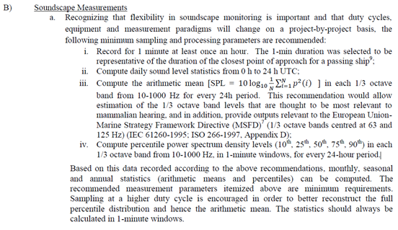
Figure 2: Extract from the report of the Leiden Sound Mapping Workshop (IWC, 2014) describing recommendations relating to averaging duration and frequency bands for soundscape measurements.

The benefit of monitoring additional frequency bands in the frequency range 10 Hz to 1000 Hz depends on the spectrum of local noise sources, on the local propagation conditions (e.g., bathymetry and seabed properties), and on the local marine fauna. It could be that sound travels best at one frequency (say 400 Hz) or that there is a particular environmental concern about the impact of another frequency (say 32 Hz). Either argument might be used to justify monitoring an additional frequency.
There is no clear benefit in monitoring underwater sound outside the range 10 Hz to 1000 Hz. The modelling costs in doing so increase disproportionately because new sources need to be taken into account (e.g., rainfall). The predominant sounds are likely to be natural ones, not anthropogenic. Figure 3 for example, suggests that shipping noise is likely to make a negligible contribution to ambient noise at frequencies of 1 kHz and higher.
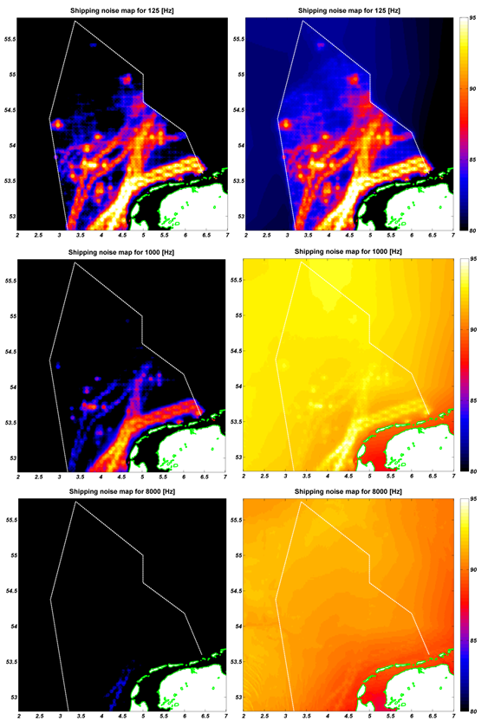
Figure 3: Left panels: shipping sound; Right panels (from EU/CEFAS report Ainslie et al. 2014): wind & shipping sound; unweighted SPL in decidecades centred at 125 Hz (upper), 1 kHz (middle), 8 kHz (lower).

8. averaging methods
The definition of “ambient noise” (Section 4) as “all sound except the sound resulting from the deployment, operation, or recovery of a receiver, and its associated platform” is not without consequence. The precise implications depend on the averaging method chosen. TSG Noise (Dekeling et al., 2014 Part 3) considered pros and cons of four different averaging methods (median, arithmetic mean (AM), geometric mean (GM) and mode). TG Noise recommends arithmetic mean and detailed reasons for this recommendation is outlined in (Dekeling et al. 2014 Part III (Section 2.8.5)). Specifically, Section 2.8.8 reads:
“What we seek is a metric of continuous ambient noise that reflects cumulative chronic effects of shipping noise. Research is needed to identify the nature and frequency of occurrence of sounds leading to relevant chronic effects. As an initial measure, TSG Noise advises MS to adopt the arithmetic mean (AM). The main considerations in reaching this recommendation are:
a) the AM includes all sounds, so there is no risk of neglecting important ones.
b) the AM is independent of snapshot duration.
The trend is the trend in the AM.
In order to establish the statistical significance of this trend, additional statistical information about the distribution is necessary. The rationale that led to Indicator 11.2.1 was associated with a concern that anthropogenic noise might mask important acoustic cues [Tasker et al., 2010]. The duration of the period of (relative) silence between intermittent sounds is an important parameter in determining potential for masking. If the ambient noise includes loud transient sounds (airgun pulses, passing ships, etc.), the potential for masking of these sounds is limited to some extent by the duration of the relatively quiet periods between these transients. If we retain only an amplitude distribution we lose this information.
For this reason, TSG Noise considers that information about time dependence is needed in addition to an amplitude distribution. Therefore, TSG Noise recommends that the complete distribution be retained in the form of sound pressure level as a function of time, with an averaging time to be specified. If it is not possible to store the full time series, TSG Noise advises to retain the amplitude distribution for this purpose in bins of 1 dB, and the associated snapshot”

The benefits of AM listed are (verbatim):
- Robust to changes or differences in sample duration
- Can be predicted using annually averaged properties of sound sources
- Compatible with Leq metric of air acoustics
- Representative of mean acoustic power
The disadvantages listed are (verbatim):
- Sensitive to outliers (extreme high values) caused by probable acquisition or processing artefacts
- Well-established metrics calculating uncertainty (variance, etc.), although these tend to work better for a Gaussian distribution, which is not expected
- Requires high dynamic range to capture
See Dekeling et al. (2014) Part 3, Section 2.8.6 for detailed discussion/justification for this recommendation.
The implications of this choice to use the AM, in combination with the agreed definition of ambient noise as including all sound other than self-noise is that some impulsive sources can make a non-negligible contribution to the indicator of continuous low frequency sound, the annually averaged ambient noise. If after initial assessment it turns out that such sounds do not affect GES, there would be a case for omitting them from the annual average, but it seems premature to assume this is the case before such an assessment is made. To omit such sounds would underestimate the annual average. While it is not yet known which sounds are most relevant for the effect addressed by indicator 11.2.1, if it becomes clear, for example, that rare but high amplitude transient sounds are not relevant, a rationale could then be developed to determine which sounds to include, and which to omit.
An important consideration for the selection of AM by TSG Noise was the robustness of this averaging method to implementation details such as choice of averaging duration. If a fixed averaging duration can be agreed, this would open the way to other choices of average, including the median (50 % exceedance level) and other percentage exceedance levels recommended at the Leiden Sound Mapping Workshop (Figure 2).

9. Summary
This Monitoring Strategy for Ambient Underwater Noise is similar to that used for modern weather forecasting and nowcasting. The monitoring is carried out primarily by modelling, supported by measurements for validation and for providing inputs to the models. A four-step approach is proposed leading to mature results in Step 4.
Based on the monitoring strategy, a monitoring programme for a specific region can be drafted. For this, the following important steps in the programme are identified:
1. Define monitoring area for specific monitoring programme
2. Describe and assess which modelling needs to be done in Step 1 of the approach;
3. Describe the measurement parameters that measurements need to comply with;
4. Make inventory of present sources and environmental parameters in monitoring area that are relevant for the spatial and temporal planning of the monitoring;
5. Assess modelling and technical aspects relevant for measurement programme;
6. Define measurement programme for specific monitoring area;
7. Assess how measurements can be used for validation of model output.

References
- Ainslie, M.A., K.L. Heaney, B. Binnerts, H. Sertlek, P.D. Theobald & T. Pangerc, 2014. Use of Sound Maps for monitoring GES: Examples and way ahead. TNO 2014 R11167: 35p.
- Dekeling et al., 2014, Monitoring guidance for underwater noise in European seas, part I, part II and part III, as adopted in OSPAR Agreement 2014-08:
  - Dekeling, R.P.A., Tasker, M.L., Van der Graaf, A.J., Ainslie, M.A, Andersson, M.H., André, M., Borsani, J.F., Brensing, K., Castellote, M., Cronin, D., Dalen, J., Folegot, T., Leaper, R., Pajala, J., Redman, P., Robinson, S.P., Sigray, P., Sutton, G., Thomsen, F., Werner, S., Wittekind, D., Young, J.V., Monitoring Guidance for Underwater Noise in European Seas, Part I: Executive Summary, JRC Scientific and Policy Report EUR 26557 EN, Publications Office of the European Union, Luxembourg, 2014, doi: 10.2788/29293
  - Dekeling, R.P.A., Tasker, M.L., Van der Graaf, A.J., Ainslie, M.A, Andersson, M.H., André, M., Borsani, J.F., Brensing, K., Castellote, M., Cronin, D., Dalen, J., Folegot, T., Leaper, R., Pajala, J., Redman, P., Robinson, S.P., Sigray, P., Sutton, G., Thomsen, F., Werner, S., Wittekind, D., Young, J.V., Monitoring Guidance for Underwater Noise in European Seas, Part II: Monitoring Guidance Specifications, JRC Scientific and Policy Report EUR 26555 EN, Publications Office of the European Union, Luxembourg, 2014b, doi: 10.2788/27158
  - Dekeling, R.P.A., Tasker, M.L., Van der Graaf, A.J., Ainslie, M.A, Andersson, M.H., André, M., Borsani, J.F., Brensing, K., Castellote, M., Cronin, D., Dalen, J., Folegot, T., Leaper, R., Pajala, J., Redman, P., Robinson, S.P., Sigray, P., Sutton, G., Thomsen, F., Werner, S., Wittekind, D., Young, J.V., Monitoring Guidance for Underwater Noise in European Seas, Part III: Background Information and Annexes, JRC Scientific and Policy Report EUR 26556 EN, Publications Office of the European Union, Luxembourg, 2014c, doi: 10.2788/2808
- Gray, L. M., & D.S. Greeley, 1980. Source level model for propeller blade rate radiation for the world’s merchant fleet. The Journal of the Acoustical Society of America, 67(2): 516-522.
- IWC, 2014. Joint workshop report: predicting sound fields—global soundscape modelling to inform management of cetaceans and anthropogenic noise. 15-16 April 2014. TNO- Gorter Building, Wassenaarseweg 56 Leiden, Netherlands.
- OSPAR Commission, Summary Record of the meeting of the Intersessional Correspondence Group on Noise (ICG-Noise), Teddington, 25-26 November 2014.
- TNO, 2009. Ainslie M.A., C.A.F. De Jong, H.S. Dol, G. Blacquière, C. Marasini, 2009. Assessment of natural and anthropogenic sound sources and acoustic propagation in the North Sea. Rapport TNO-DV 2009 C085, TNO, Den Haag.
- Verfuß, U.K., M. Andersson, T. Folegot, J. Laanearu, R. Matuschek, J. Pajala, P. Sigray, J. Tegowski & J. Tougaard, 2014. BIAS Standards for noise measurements. Background information, Guidelines and Quality Assurance. 71 p.
- Van der Graaf A.J., M.A. Ainslie, M. André, K. Brensing, J. Dalen, R.P.A. Dekeling, S. Robinson, M.L. Tasker, F. Thomsen & S. Werner, 2012. European Marine Strategy Framework Directive - Good Environmental Status (MSFD GES): Report of the Technical Subgroup on Underwater noise and other forms of energy. 75p.
- Wales, S. C., & R.M. Heitmeyer, 2002. An ensemble source spectra model for merchant ship-radiated noise. The Journal of the Acoustical Society of America, 111(3): 1211-1231.

Websites:
- European Research project SONIC (http://www.sonic-project.eu/)
- European Research project AQUO (http://www.aquo.eu/)

3.6.1.3 acoustic self-noise: sound resulting from the deployment, operation, or recovery of a receiver, and its associated platform.
3.6.1.4 reverberation: contribution to the sound field due to unwanted reflections or scattering from objects such as fish, bubbles, the sea surface and seabed

